|  |
| --- |
| IFMR RURAL FINANCE |
| Lead Generation |
|  |
| **Rahul Prakash / Sarthak Shah | IFMR Rural Finance** |
| **12/9/2016** |

|  |
| --- |
|  |

Contents

1. Process Diagram 4

2. Stage definition 5

3. Stage-role access 6

4. Bulk lead data upload 7

4.1 UI specification (Data Upload File) 7

4.2 Screenshot 7

4.3 Functional Requirements 7

4.4 Uploads 7

4.5 Downloads 7

4.6 Reports 7

5. assigning leads (ASSIGNMENT PENDING QUEUE) 8

5.1 UI Requirements (Assignment Pending) 8

5.2 Screenshots 8

5.3 Functional Requirements 9

5.4 Uploads 10

5.5 Downloads 10

5.6 Reports 10

6. Capturing Lead Details & Decision Making 11

6.1 UI Requirements (data Fields) 11

6.2 Screenshots 16

6.3 Functional Requirements 19

6.4 Uploads 20

6.5 Downloads 20

6.6 Reports 20

7. Incomplete Leads Queue 21

7.1 UI Requirements (data Fields) 21

7.2 Screenshots 21

7.3 Functional Requirements 22

7.4 Uploads 23

7.5 Downloads 23

7.6 Reports 23

8. follow- up queue 24

8.1 UI requirements (Queue Layout) 24

8.2 Screenshots 24

8.3 Functional requirements 25

8.4 Uploads 26

8.5 Downloads 26

8.6 Reports 26

# Process Diagram

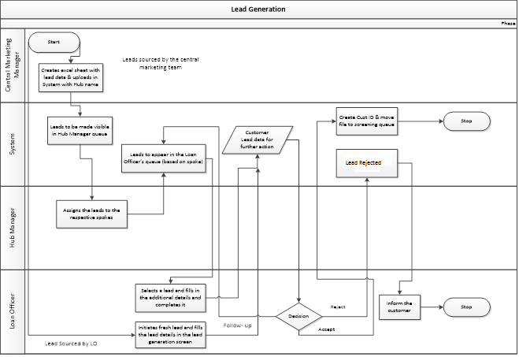

# Stage definition

|  |  |
| --- | --- |
| **Stage** | **Description** |
| Bulk Lead data Upload | The central marketing team creates an excel with the list of leads and uploads the excel with hub name in the system |
| Assigning Leads | Hub Manager assigns leads to a respective spoke. All such leads will be stored in “Incomplete Leads” queue |
| Capturing Lead details & Decision making | The loan officer uses the Lead generation screen to fill details about a specific lead, either by creating a fresh lead or working on ones assigned by the hub manager. |
| Incomplete Leads Queue | For cases where leads are assigned by the hub manager, in order to capture complete information, loan officer selects a lead from the Incomplete Leads queue. |
| Follow up queue | The leads kept for follow up are actioned upon on the follow- up date. |

# Stage-role access

|  |  |
| --- | --- |
| **Stage** | **Applicable Role** |
| Bulk Lead Data Upload | Central Marketing Team |
| Assigning Leads | Hub Manager |
| Capturing Lead details & Decision making | Loan Officer |
| Incomplete Leads Queue | Loan Officer |
| Follow up queue | Loan Officer |

# Bulk lead data upload

## UI specification (Data Upload File)



## Screenshot

N.A.

## Functional Requirements

1. **Central Marketing Manager** logs in.
2. Creates an excel with the list of leads (according to the format shared and agreed) and uploads excel with respective hub name for each leads, in the system.
3. Leads to be uploaded in the system and same should appear in the respective Hub Manager login (based on the hub, hub manager is mapped to).
4. After successful upload, the status of these leads can be “assignment pending”

## Uploads

The lead data upload spreadsheet

## Downloads

NA

## Reports

Lead Generation report

# assigning leads (ASSIGNMENT PENDING QUEUE)

## UI Requirements (Assignment Pending)

|  |  |  |  |  |
| --- | --- | --- | --- | --- |
| **Field name** | **Section** | **Data Type** | **Attribute** | **Population logic** |
| **S. No.** | **Assigning Leads** | **Numeric** |  |  |
| **Upload Date** | **Assigning Leads** | **date** | **Sort/search** | **Auto-populated(From uploaded file during bulk data upload)** |
| **Lead Name** | **Assigning Leads** | **Text** | **Sort/search** | **Auto-populated(From uploaded file during bulk data upload)** |
| **Business Name** | **Assigning Leads** | **Alphanumeric** | **Sort/search** | **Auto-populated(From uploaded file during bulk data upload)** |
| **Address** | **Assigning Leads** | **Alphanumeric** |  | **Auto-populated(From uploaded file during bulk data upload)** |
| **Area** | **Assigning Leads** | **Text** | **Sort/search** | **Auto-populated(From uploaded file during bulk data upload)** |
| **City/Village/Town** | **Assigning Leads** | **Text** | **Sort/search** | **Auto-populated(From uploaded file during bulk data upload)** |
| **Pincode** | **Assigning Leads** | **Numeric** |  | **Auto-populated(From uploaded file during bulk data upload)** |

## Screenshots

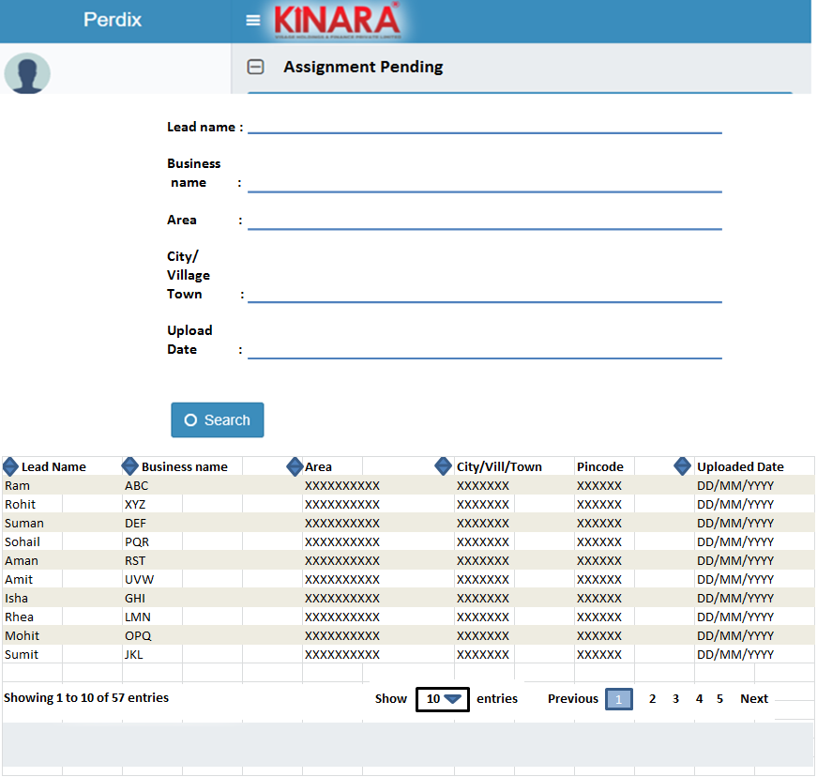

## Functional Requirements

**Hub Manager** logs in,

* 1. The hub manager will assign leads which are in “assignment pending” stage.
  2. The Hub Manager in turn assigns the leads to the respective spoke from the ‘Assignment Pending’ queue. Upon selecting the assignment pending queue, all the cases pertaining to the particular hub need to be listed in a tabulation (**based on the Hub ID**). Leads are assigned to a spoke by selecting from a dropdown of all the spokes mapped to that particular hub. Prior to assignment, the hub manager can **sort** these leads based on the following parameters: Upload date, Applicant Name, Business Name, Area, City/Village/town.
  3. Once assigned, leads should appear in the Loan Officer’s log-in (based on the spoke he is mapped to- **using spoke ID**).
  4. An option to reassign the lead needs to be provided in case the lead is erroneously assigned.
  5. After successful assignment, lead status can be “Assigned”.

## Uploads

N.A.

## Downloads

N.A.

## Reports

Lead Generation Report

# Capturing Lead Details & Decision Making

## UI Requirements (data Fields)

|  |  |  |  |  |  |  |  |  |
| --- | --- | --- | --- | --- | --- | --- | --- | --- |
| **Section** | **Sub section** | **Main Field Name** | **Field Value** | **Mandatory** | **Conditonal Mandatory** | **Attribute** | **Validation** | **Population Logic** |
| Lead Profile |  | Hub Name | Alphanumeric | Yes |  | Auto populate |  | Based on log in |
|  | Spoke Name | Alphanumeric | Yes |  | Auto populate/Dropdown |  | Based on log in. If a loan officer is mapped to more than one spoke then select option |
|  |  |  |  |  |  |  |  |
| Lead Details | Lead Name | Text | Yes |  |  |  |  |
| Entity Type | Text | Yes |  | Dropdown |  | Individual / Enterprise |
|  |  |  |  |  |  |  |  |
| Individual Details | Gender | Text |  |  | radio select |  | Male/Female/Unspecified- If entity type= individual |
| Age | Numeric |  |  | Autocalculate |  | If entity type= individual |
| Date of Birth | Date |  |  |  |  | If entity type= individual |
| Marital Status | Text |  |  | dropdown |  | Divorced/Married/Single/Widow- If entity type= individual |
| Education Status |  |  |  |  |  | Below SSC,SSLC,HSC,Graduate/Diploma/ITI,Professional Degree,Others- If entity type= individual |
|  |  |  |  |  |  |  |  |
| Enterprise Details | Business Name | alphanumeric |  | Yes | Read/Write |  | If entity= Enterprise |
| Business Type | Text |  | Yes | Dropdown |  | Refer lead dropdowns (If entity= Business)- If entity= Enterprise |
| Business Activity | Text |  | Yes | Dropdown |  | Refer lead dropdowns (If entity= Business)- If entity= Enterprise |
| Operating Since | Date |  |  | Dropdown |  | If entity= Enterprise |
| Ownership | Text |  |  | dropdown |  | Owned, Rented, Leased- If entity= Enterprise |
| Is the Business Registered ? | Text |  |  | radio select |  | Yes/No- If entity= Enterprise |
|  |  |  |  |  |  |  |  |
| Contact Details | Mobile No 1 | Numeric | Yes |  | Read/Write | 10 digits |  |
| Alternate mobile number | Numeric |  |  | Read/Write | 10 digits |  |
| Address Line 1 | alphanumeric | Yes |  | Read/Write |  |  |
| Address Line 2 | alphanumeric |  |  | Read/Write |  |  |
| Pin code | Numeric | Yes |  | Dropdown | 6 digits | Pincode master |
| State | Text |  |  | Auto populate |  | Based on Pincode State and Distric should autopopulate |
| District | Text |  |  | Auto populate |  | Based on Pincode State and Distric should autopopulate |
| Location | GPS |  |  |  |  |  |
| Area | Text | Yes |  | Dropdown |  | (Search Option). Based on the respective spoke. Dropdown options required |
| Product Details |  |  |  |  |  |  |  |  |
|  | Product Category | Text | Yes |  | Dropdown |  | Asset / Liability/Others |
|  | Product Sub- Category | Text | Yes |  | Dropdown |  | Refer lead dropdowns |
|  | Interested In product | Text | Yes |  | Dropdown |  | Yes/No |
|  | Product Required by ? | Text |  | yes | Dropdown |  | Refer Lead Dropdowns tab. Product category asset and sub category loan (To be populated if the answer to "interested in product is Yes") |
|  | Please enter the screening date | Date |  | Yes | Read/Write |  | If interested & and loan required by ?- within this week |
|  | Please enter the follow up date | Date |  | Yes | Read/Write |  | If interested & and loan required by ?- other than within this week |
|  | Remarks | Alphanumeric (free text) |  |  | Read/Write |  | If interested and loan required by ?- other than within this week |
|  | Loan purpose | Text |  | yes | Dropdown |  | Refer Lead Dropdowns tab. Product category asset and sub category loan (To be populated if the answer to "interested in product is Yes") |
|  | Loan Amount Requested | Numeric |  | Yes | Read/Write |  | Product category asset and sub category loan (To be populated if the answer to "interested in product is Yes") |
| Product Eligibility | Eligible for Product | Text |  | Yes | Radio Select |  | Yes/No- If interested in product is selected as Yes |
| Reason | Dropdown |  | Yes | Dropdown |  | Dropdown: Not our target segment |
| Additional remarks | Alphanumeric (free text) |  |  | Read/Write |  | (To be populated if the answer to "eligible for product is No") |
|  |  |  |  |  |  |  |  |
| Product Rejection Reason | Reason | Dropdown |  | Yes | Dropdown |  | Refer Lead dropdowns- (To be populated if the answer to "interested in product is No") |
| Additional remarks | Alphanumeric (free text) |  |  | Read/Write |  | (To be populated if the answer to "interested in product is No") |
| Lead Status | Lead Status | Text | Yes |  | Read/Write |  | Customer/Follow-up/Hold/Reject |
| Note: For all other product category/ sub category combinations, 3 sets of Field name/Field Values to be populated- Field name-1, Field name-2, Field name- 3 | | | | | | | |
| Customer Interactions |  | Interaction Date | Date | Yes |  |  |  | Auto Populate |
|  | Action Taken by (Loan Officer ID) | Alphanumeric | Yes |  |  |  | Auto Populate (based on login) |
|  | Type of interaction | Text | Yes |  | Dropdown |  | Call / Visit |
|  | Location | GPS |  | Yes | GPS |  | if visit |
|  | Picture | Picture |  | Yes | Picture |  | if visit |
|  | Customer Response | Alphanumeric | Yes |  |  |  |  |
|  | Additional remarks | Alphanumeric |  |  |  |  |  |
| Note: A separate tab "Interactions History" to contain all previous customer interaction details in the above mentioned format | | | | | | | |
| Interaction History | Interaction Date | Date | Yes |  |  |  | Based on previous interaction |
| Action Taken by (Loan Officer ID) | Alphanumeric | Yes |  |  |  | Based on previous interaction |
| Type of interaction | Text | Yes |  | Dropdown |  | Based on previous interaction |
| Location | GPS |  | Yes | GPS |  | Based on previous interaction |
| Picture | Picture |  | Yes | Picture |  | Based on previous interaction |
| Customer Response | Alphanumeric | Yes |  |  |  | Based on previous interaction |
| Additional remarks | Alphanumeric |  |  |  |  | Based on previous interaction |

## Screenshots

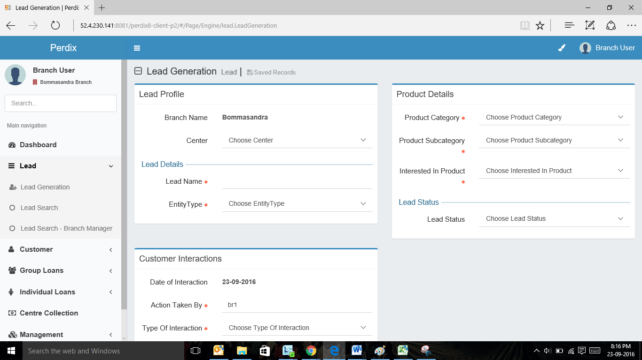

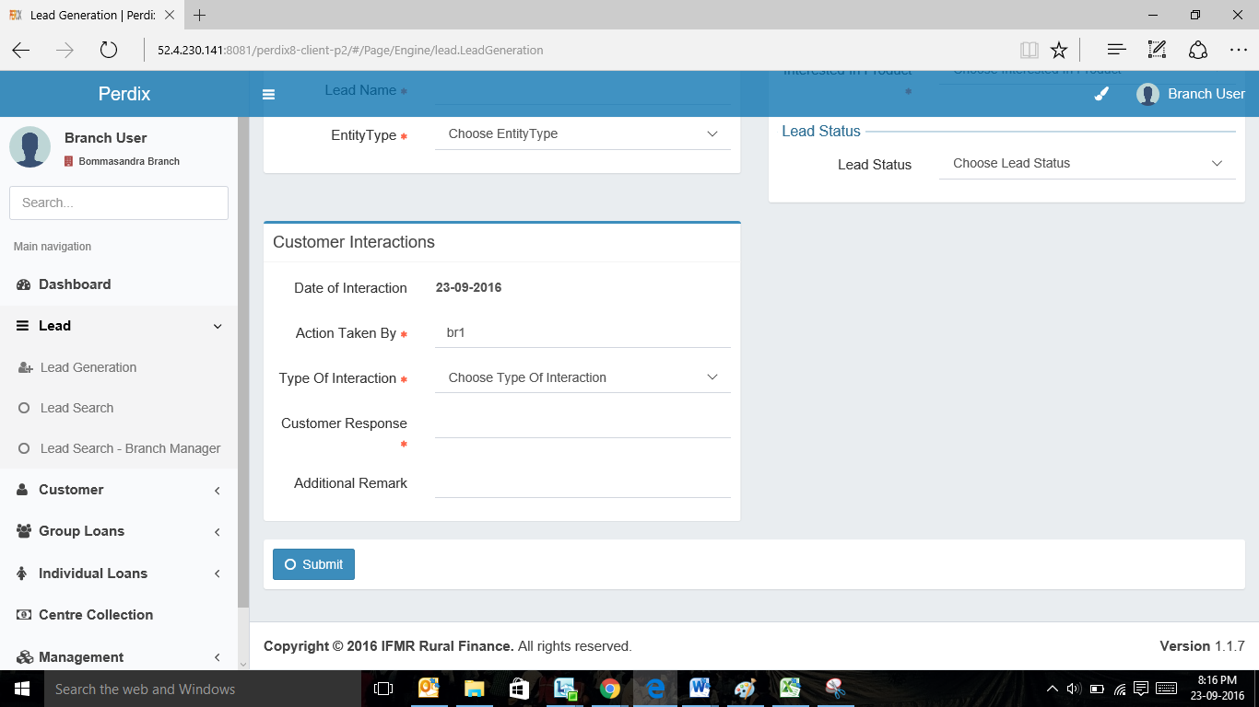

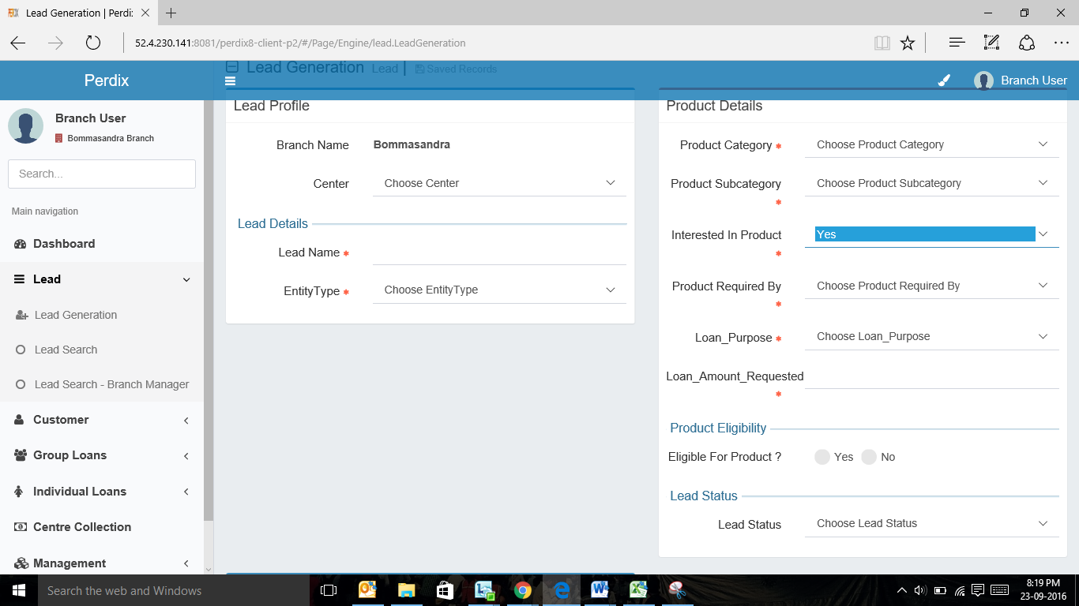

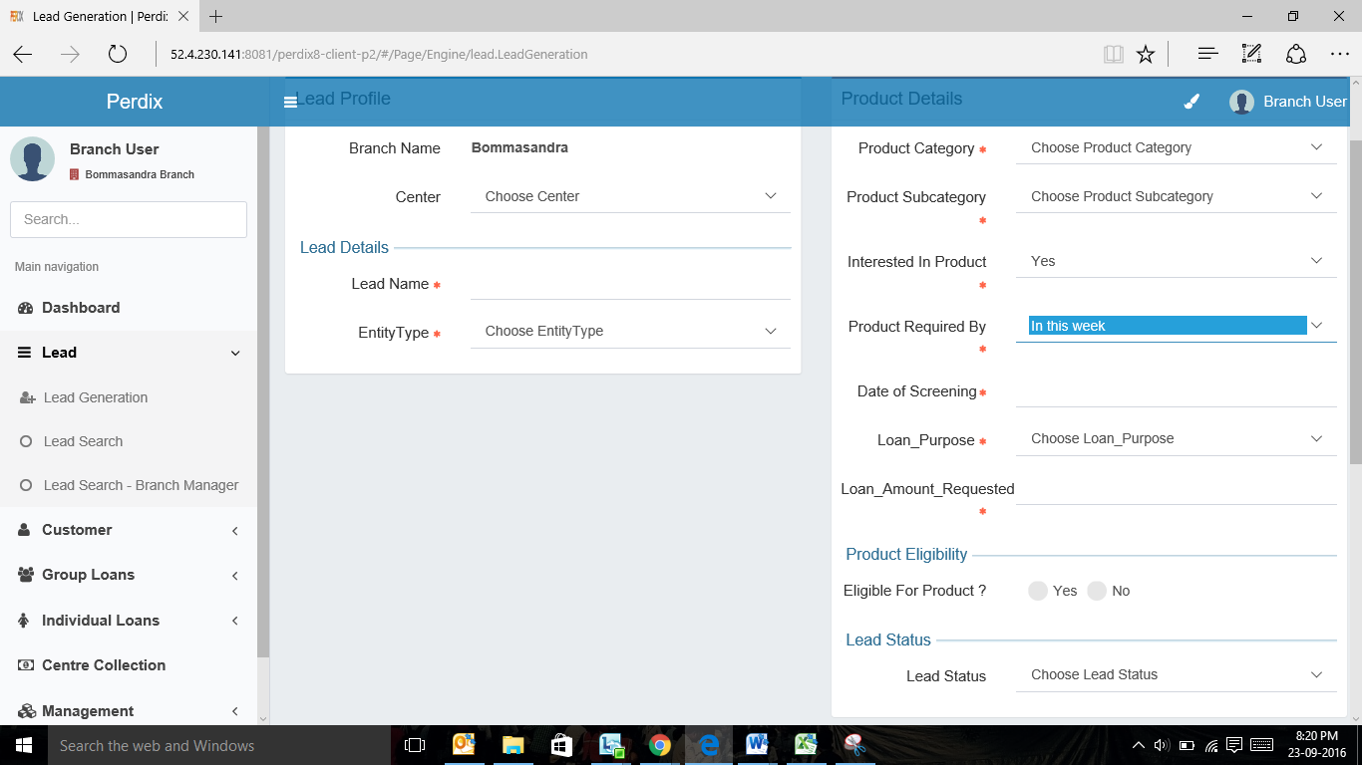

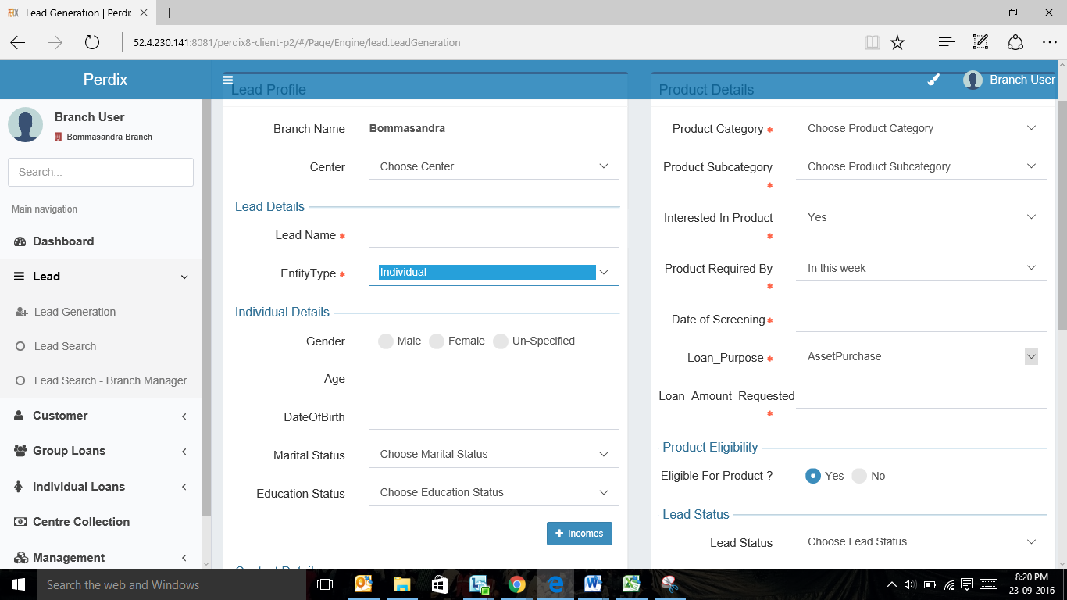

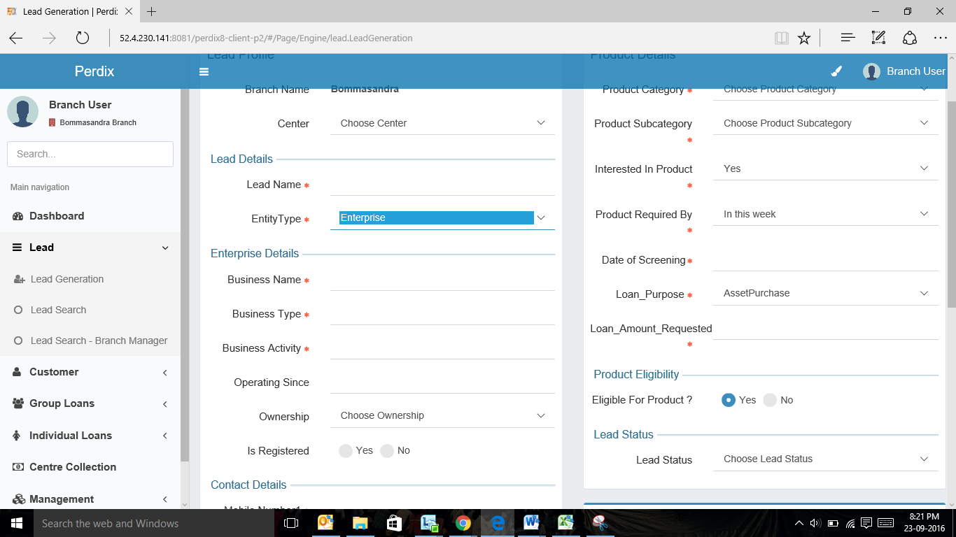

## Functional Requirements

**Loan Officer Logs** in

1. For leads generated by the Loan officer, the loan officer uses the ‘Create New Lead’ screen to fill details about a specific lead.
2. Loan officer to capture the relevant data including the customer interaction information.
3. Based on the lead details captured, there would be various outcomes. If the “Interested in Product” field is captured as “no”, the loan officer needs to select the reason for the same. The profile is automatically rejected (status) upon submission.
4. If the loan officer finds the lead ineligible to avail the product, the field “Eligible for Product” is selected as “No”, and then the Loan officer needs to select rejection reason and the profile is rejected (status) upon submission.
5. If an eligible lead requires the product immediately (within this week), then loan officer to enter screening date. Upon submission, customer ID is generated and the lead is moved to screening queue and its status can be changed to “Pending for Screening.”
6. If an eligible lead requires the product later, then the loan officer to enter follow-up date. The profile is sent to follow-up queue upon submission. Upon successfully adding lead for follow-up the status of the lead can be changed as “Follow up”

## Uploads

## Downloads

## Reports

1. Lead Management Funnel - Number of leads generated, number of approved, number of rejected, number of follow- up and number of disbursed
2. Lead Category Report- Hot, Warm, and Cold (based on the “product required by” field

# Incomplete Leads Queue

## UI Requirements (data Fields)

|  |  |  |  |  |
| --- | --- | --- | --- | --- |
| **Field name** | **Section** | **Data Type** | **Attribute** | **Population logic** |
| **S. No.** | **Incomplete Queue** | **Numeric** |  |  |
| **Assigned Date** | **Incomplete Queue** | **date** | **Sort** | **Auto-populated(From uploaded file during bulk data upload)** |
| **Lead Name** | **Incomplete Queue** | **Text** | **Sort/search** | **Auto-populated(From uploaded file during bulk data upload)** |
| **Business Name** | **Incomplete Queue** | **Alphanumeric** | **Sort/search** | **Auto-populated(From uploaded file during bulk data upload)** |
| **Address** | **Incomplete Queue** | **Alphanumeric** |  | **Auto-populated(From uploaded file during bulk data upload)** |
| **Area** | **Incomplete Queue** | **Text** | **Sort/search** | **Auto-populated(From uploaded file during bulk data upload)** |
| **City/Village/Town** | **Incomplete Queue** | **Text** | **Sort/search** | **Auto-populated(From uploaded file during bulk data upload)** |
| **Pincode** | **Incomplete Queue** | **Numeric** |  | **Auto-populated(From uploaded file during bulk data upload)** |

## Screenshots

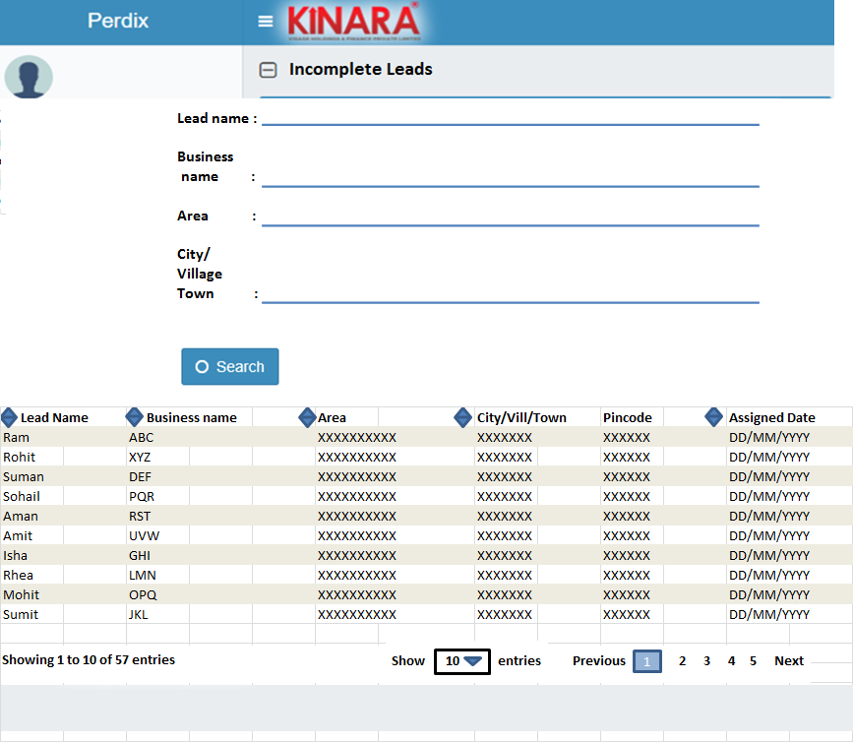

## Functional Requirements

**Loan Officer Logs** in

1. The loan officer opens the Incomplete Leads queue. All the leads with possible “Assigned” status will be displayed here. Upon entering the incomplete lead queue, the loan officer can **search** for the leads using the following parameters: Assigned date, applicant name, business name and area. The result needs to be populated as a table (UI purpose). The loan officer can **sort** the incomplete leads based on the following parameters: Assigned date, Applicant Name, Business Name, Area, City/Village/Town. The loan officer then selects a lead from the incomplete leads queue (which was previously assigned to the respective spoke by the hub manager) and will start capturing the required information in the same way as explained in step 6.

## Uploads

N.A.

## Downloads

N.A.

## Reports

# follow- up queue

## UI requirements (Queue Layout)

|  |  |  |  |  |
| --- | --- | --- | --- | --- |
| **Field name** | **Section** | **Data Type** | **Attribute** | **Population logic** |
| **S. No.** | **FollowUp Queue** | **Numeric** |  |  |
| **Follow up Date** | **FollowUp Queue** | **date** | **Sort/Search** | **From data captured** |
| **Lead Name** | **FollowUp Queue** | **Text** | **Sort/Search** | **From data captured** |
| **Business Name** | **FollowUp Queue** | **Alphanumeric** | **Sort/Search** | **From data captured** |
| **Address** | **FollowUp Queue** | **Alphanumeric** |  | **From data captured** |
| **Area** | **FollowUp Queue** | **Text** | **Sort/Search** | **From data captured** |
| **City/Village/Town** | **FollowUp Queue** | **Text** | **Sort/search** | **From data captured** |
| **Pin code** | **FollowUp Queue** | **Numeric** |  | **From data captured** |

## Screenshots

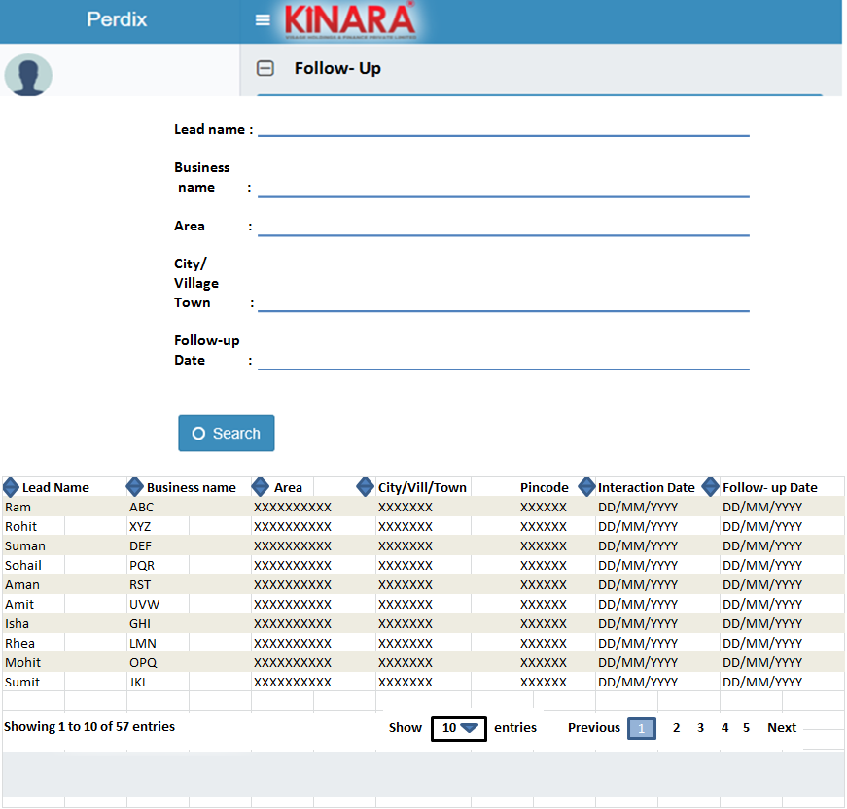

## Functional requirements

**Loan Officer** logs in

* 1. The loan officer enters the Follow- up queue. Upon entering the Follow- up queue, the loan officer can **search** for the leads using the following parameters: Follow- up date, applicant name, business name, area and City/Village/Town. The result needs to be populated as a table. The loan officer can sort these leads based on the following parameters: Follow up date, Applicant name, Business name, Area, City/Village/Town. The loan officer then selects a lead from the Leads in the Follow- up queue.
  2. Loan officer to follow up with the customer, update the fields and take a decision on the lead status (follow step 6). Accordingly the lead status will be updated.

## Uploads

## Downloads

## Reports

Number of leads to follow- up, responded and turned down.